**CMPE 283**

**Virtualization**

**Assignment 1:**

Create an instance with nested virtualization using the script generated by **“Equivalent Command Line”** by running the script in cloud shell.

Add the script “ **--min-cpu-platform "Intel Cascade Lake" --enable-nested-virtualization”** to enable nested virtualization while running an instance creation script in cloud shell.

Script to create an instance :

**~~gcloud compute instances create instance-2 --project=encoded-joy-367817 --zone=us-west4-b --machine-type=n2-standard-8 --network-interface=network-tier=PREMIUM,subnet=default --metadata=ssh-keys=spartan:ssh-ed25519\ AAAAC3NzaC1lZDI1NTE5AAAAIOsVZHXOQpblHj5TC\+arWq\+HQYCdmW52ddWUXUTm4wJj\ spartan@IMS-065MBA.local --maintenance-policy=MIGRATE --provisioning-model=STANDARD --service-account=564762864892-compute@developer.gserviceaccount.com --scopes=https://www.googleapis.com/auth/devstorage.read_only,https://www.googleapis.com/auth/logging.write,https://www.googleapis.com/auth/monitoring.write,https://www.googleapis.com/auth/servicecontrol,https://www.googleapis.com/auth/service.management.readonly,https://www.googleapis.com/auth/trace.append --create-disk=auto-delete=yes,boot=yes,device-name=instance-2,image=projects/ubuntu-os-cloud/global/images/ubuntu-1804-bionic-v20221018,mode=rw,size=100,type=projects/encoded-joy-367817/zones/us-west4-b/diskTypes/pd-ssd --no-shielded-secure-boot --shielded-vtpm --shielded-integrity-monitoring --reservation-affinity=any~~**

Script to make it as a nested virtualized instance:

**--min-cpu-platform "Intel Cascade Lake" --enable-nested-virtualization**

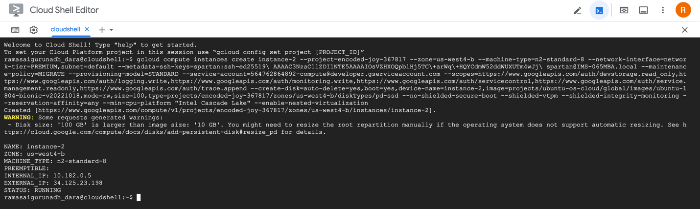

Configuration has been set as shown below before running the script.

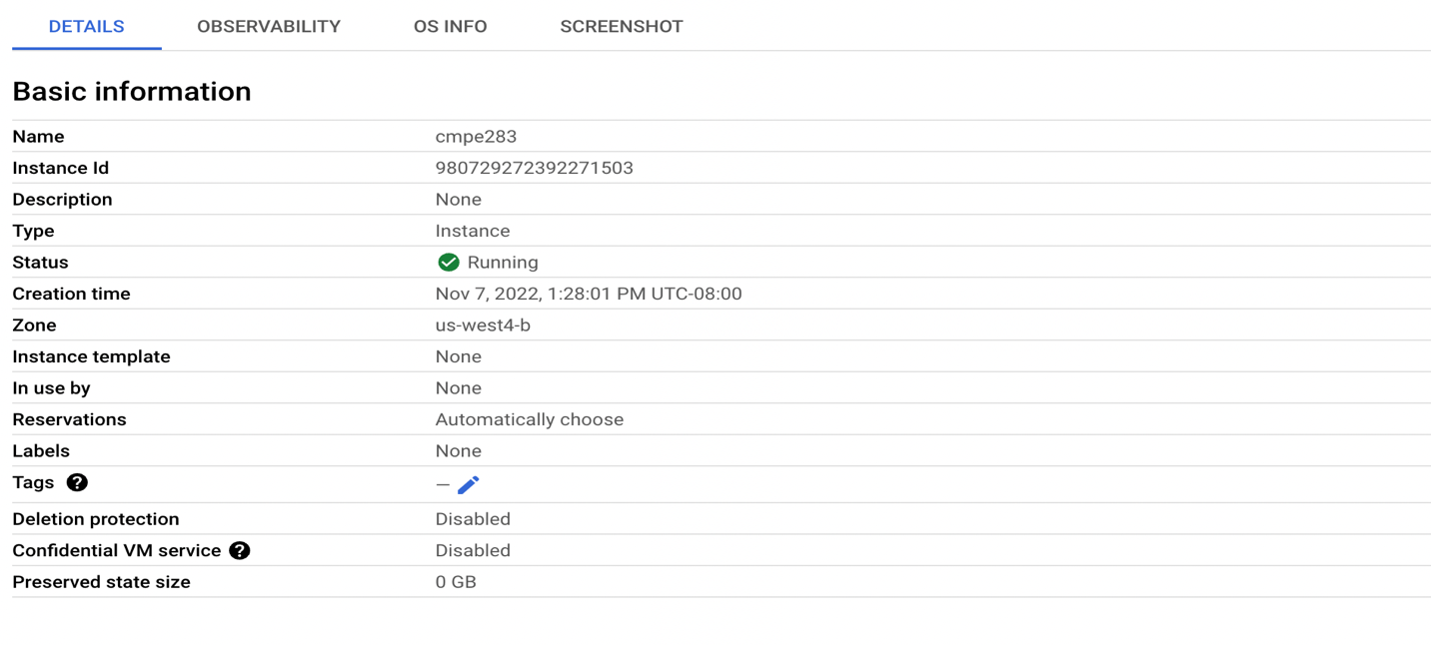

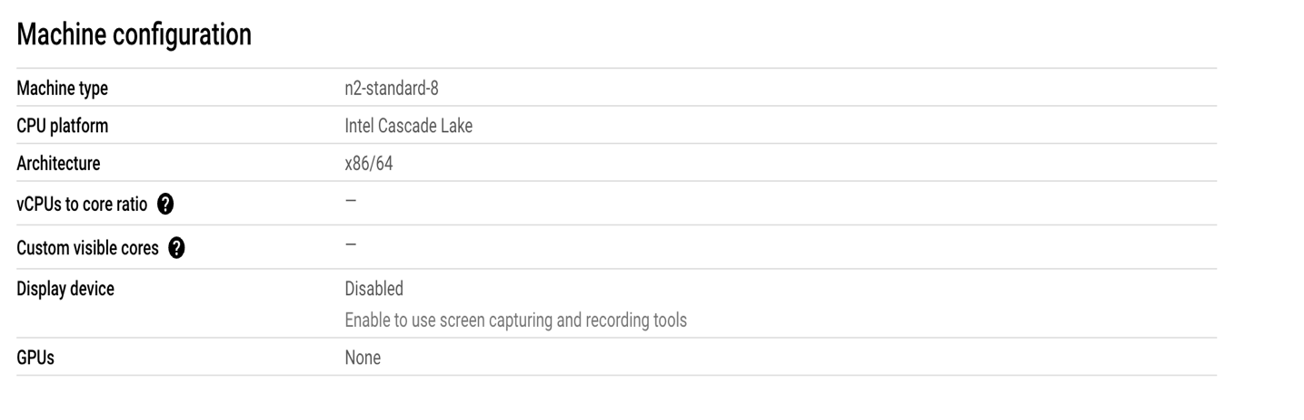

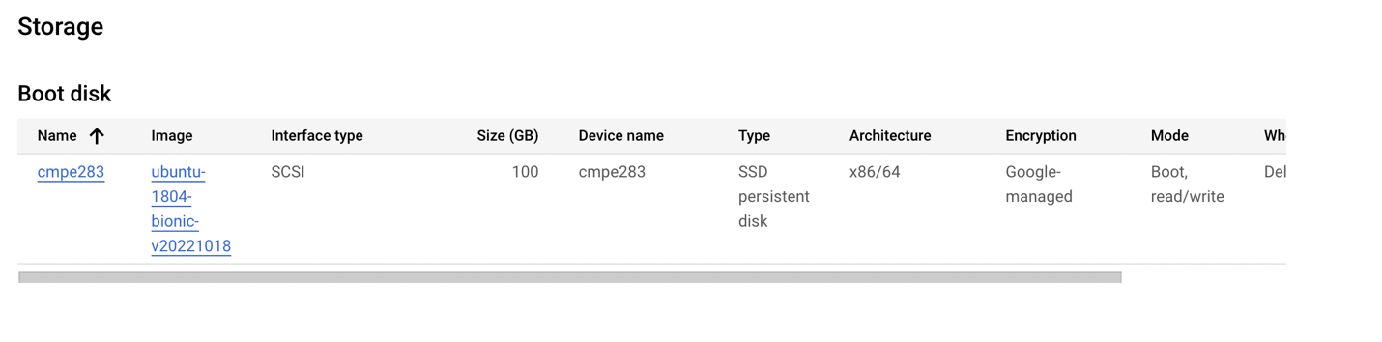

SSH into the instance using **SSH** option under connect.

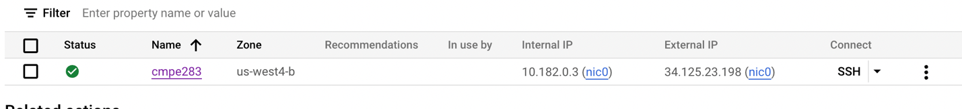

After getting into an instance, create a directory using below command.

* $ mkdir cmpe283

Create .c and make files in the directory.

* .c consisting of the code with capabilities of pinbased, primary_procbased, secondary_procbased, entry

Controls and exit controls.

* Make file is used for compilation



Once the files are created, install the required libraries using below command.

* $ sudo apt-get update

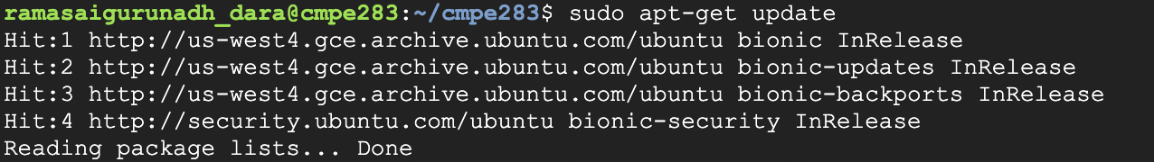

* $ sudo apt-get upgrade

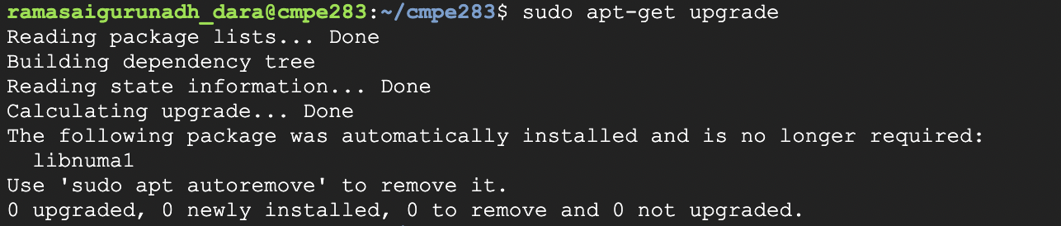

To install libraries of **gcc** and **make**  use below command

* $ sudo apt-get install vim gcc make linux-headers-$(uname -r)

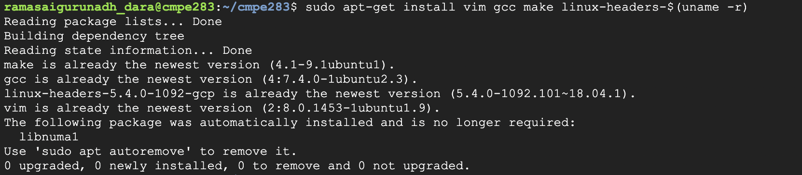

* Run **“$ make”** command to initiate the compilation, it generates the .ko file which generates kernel object file.

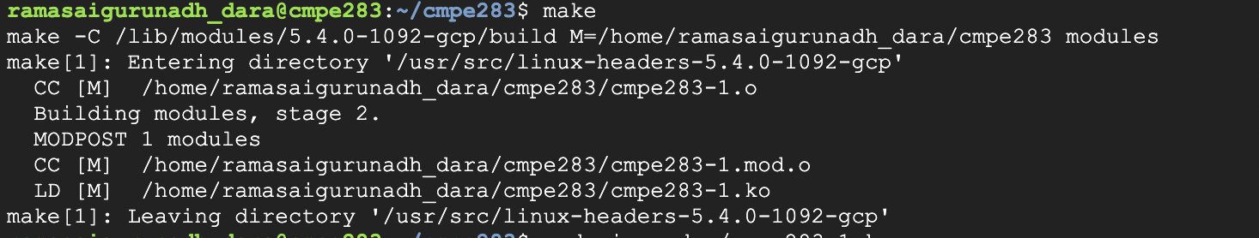

Once the code is run it generates the .ko, .mod, .mod.o, .o, modules.order, Module.symvers files.

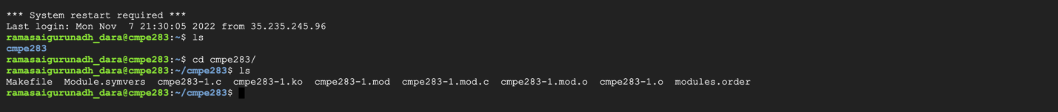

* $ sudo insmod ./cmpe283-1.ko
* Run the code using the command $ sudo dmesg

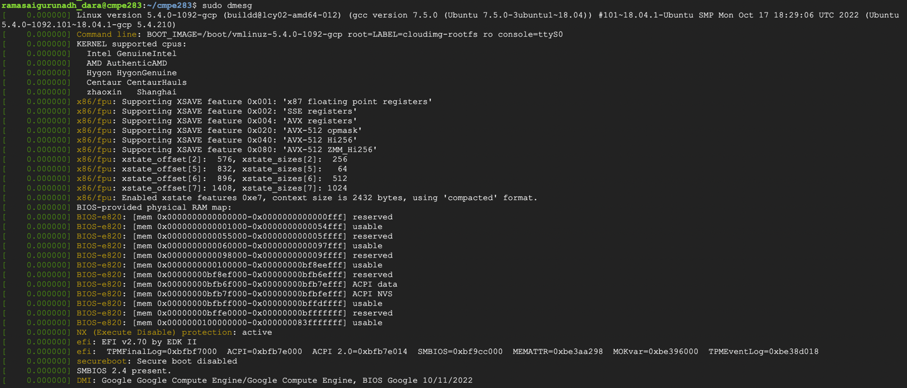

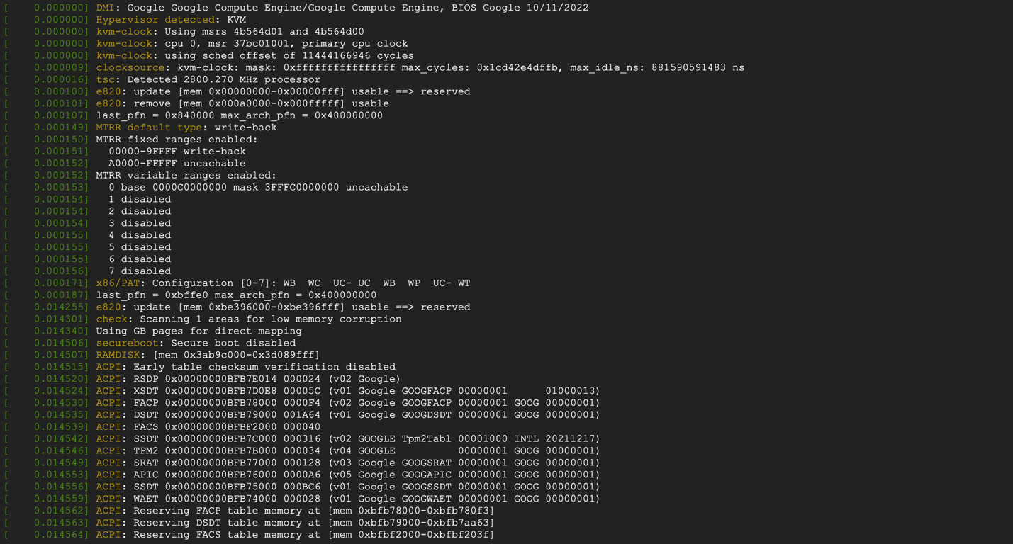

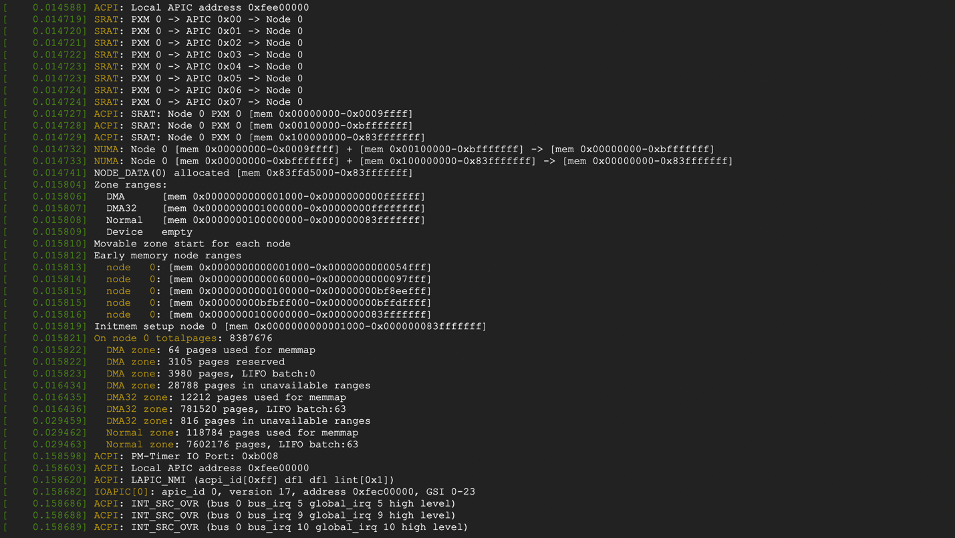

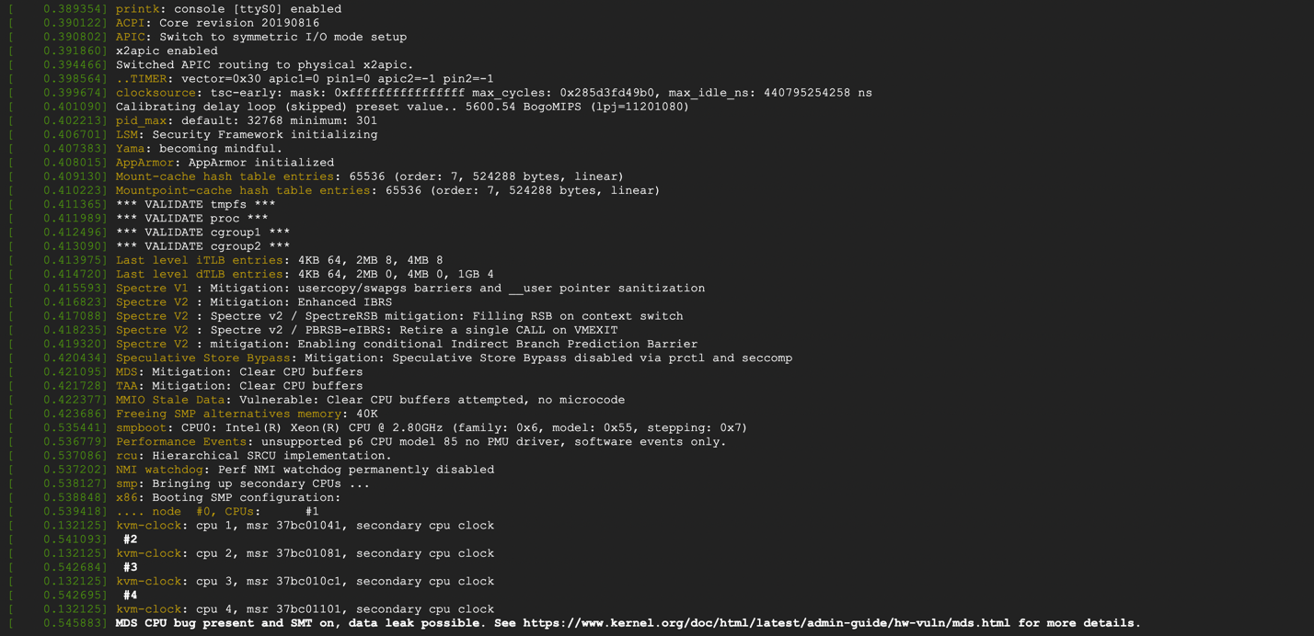

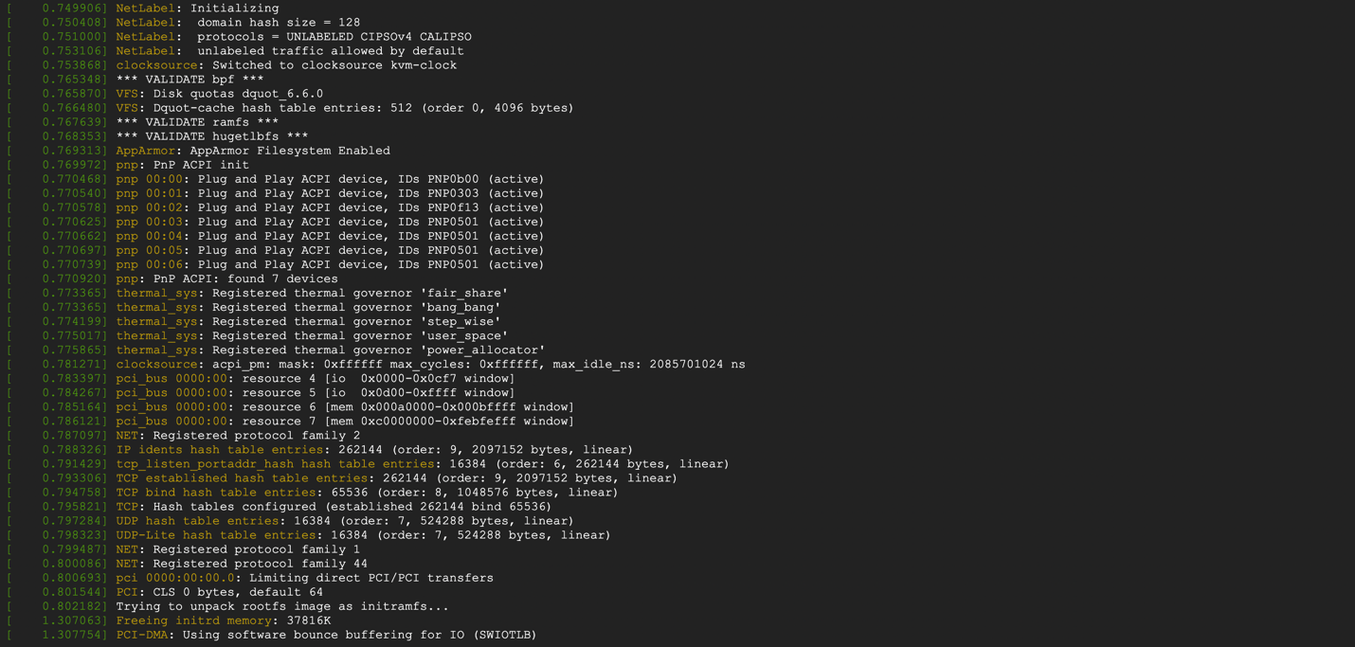

Output:

